EXP.NO:4

230701217-NITHIN KUMAR K

Create a prototype with familiar and unfamiliar navigation elements. Evaluate ease of use with different user groups using proto.io

AIM: The aim is to develop a prototype incorporating both familiar and novel navigation elements and assess usability among diverse user groups using Proto.io.

PROCEDURE: i) Example 1:

Tool Link: <https://proto.io/>

Step 1: Sign Up and Log In

1. Go to proto.io.
2. 2. Sign up for a new account or log in if you already have one.

Step 2: Create a New Project

1. Click on "Create New Project."

2. Give your project a name (e.g., "Simple App Example").

3. Select the device type (e.g., Mobile - iPhone X).

4. Click "Create" to start the project.

Step 3: Design the Home Screen

1. Add a New Screen: ○ Click on the "+" button in the left panel to add a new screen. ○ Choose "Blank" and name it "Home."

2. Add Elements to the Home Screen: ○ Drag a "Header" widget from the "Widgets" panel to the top of the screen. ○ Double-click the header to edit the text and change it to "Home Screen." ○ Drag a "Button" widget onto the screen. Place it in the center. ○ Double-click the button to edit the text and change it to "Go to Profile."

3. Add Interaction: ○ Select the button and click on the "Interactions" tab on the right panel. ○ Click "+ Add Interaction." ○ Set the trigger to "Tap/Click." ○ Set the action to "Navigate to Screen" and choose "New Screen." ○ Create a new screen and name it "Profile."

# IMAGE:1

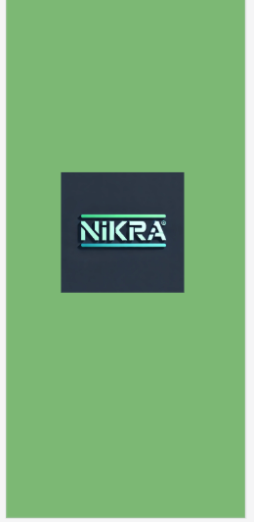

# IMAGE 2:

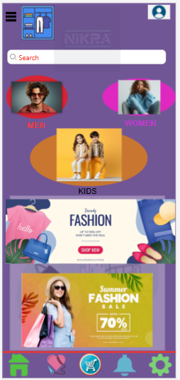

Step 4: Design the Profile Screen

1. Add Elements to the Profile Screen: ○ On the newly created Profile screen, drag a "Header" widget to the top of the screen. ○ Double-click the header to edit the text and change it to "Profile Screen." ○ Drag an "Image" widget onto the screen. Place it below the header. ○ Double-click the image to upload a profile picture or any placeholder image. ○ Drag a "Text" widget onto the screen to add some profile information (e.g., "John Doe, Software Engineer").

2. Add Back Button: ○ Drag a "Button" widget onto the screen. ○ Double-click the button to edit the text and change it to "Back to Home."

3. Add Interaction: ○ Select the button and click on the "Interactions" tab on the right panel. ○ Click "+ Add Interaction." ○ Set the trigger to "Tap/Click." ○ Set the action to "Navigate to Screen" and choose "Home."

Step 5: Preview the Prototype

1. Click on the "Preview" button in the top-right corner.

2. Interact with the prototype by clicking on the buttons to navigate between the Home and Profile screens.

Step 6: Share the Prototype

1. Click on the "Share" button in the top-right corner.

2. Copy the shareable link and send it to others for feedback.

-----------🡪 <https://pr.to/TWGWMJ/>

1. Example 2:

Step 1: Plan Your Prototype

1. Identify Your Elements: ○ Familiar: Common navigation elements such as a top menu bar, side panels, breadcrumb trails, and footer links. ○
2. Unfamiliar: Experiment with things like hidden menus, gesture-based navigation, or voice commands. 2. Sketch Out Your Concept: ○ Draft wireframes on paper, using tools like Figma or Sketch to visualize how both elements will coexist.

# ---🡪Familiar: Common navigation elements such as a top menu bar, side panels, MEN,WOMEN,KIDS,SETTINGS, and footer links.

# -🡪Unfamiliar: Experiment with things like hidden menus, gesture-based navigation, or voice commands(SEWING HEART-FOR SAVING/ ADD THE WISHING THINGS TO THAT PERSONALISED PAGE) and WARDROBE ICON-INSTEAD OF “ADD TO CART”, WE CAN ADD ITEMS HERE LIKE A RACK LIKE ICON(WHICH IS UNFAMILIAR FOR THE USERS).

Step 2: Start Your Project on Proto.io

1. Sign Up/Log In: Go to Proto.io and either create an account or log in if you already have one.
2. 2. Create New Project: ○ Click on the “Create a new project” button, select the type of project, and give it a name.
3. 3. Choose a Template: ○ Select a template that suits your needs or start from scratch.

Step 3: Design Your Screens

1. Familiar Navigation: ○ Drag and drop elements like menus, tabs, buttons that users are accustomed to.

2. Unfamiliar Navigation: ○ Add unique elements such as swipe gestures, hover interactions, or voice commands. 3. Link Screens: ○ Use Proto.io’s interaction design tools to set up transitions between screens

# IMAGE:3(FAMILIAR)

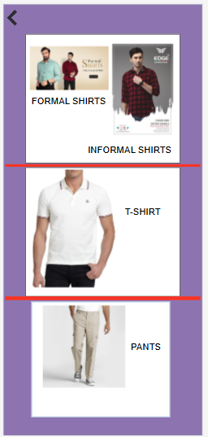

IF YOU CLICK “MEN”, THEN IT WILL SET TO THE NEXT SCREEN, WHERE YOU CAN SEE THE TYPES AND COLLECTION OF THE MALE CLOTHS. THIS IS A FAMILIAR ICON FOR THE USERS

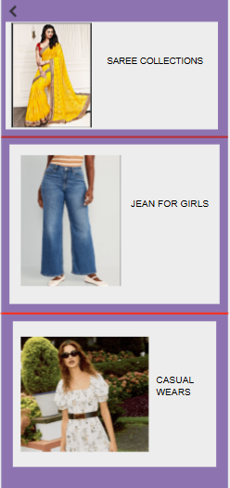

IMAGE :4

# IMAGE :5 [MENU ICONS]-FAMILIAR:

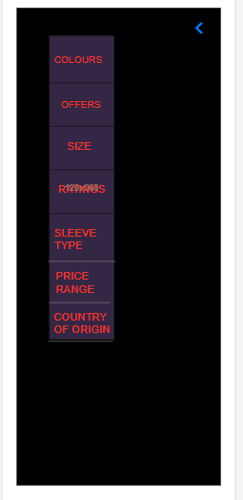

# IMAGE:6 [FAMILIAR]

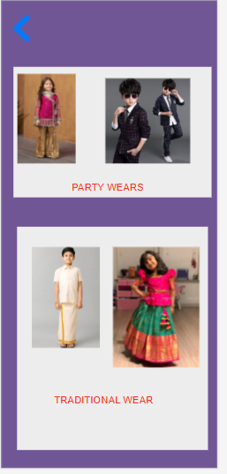

# IMAGE:7-WARDROBE RACK[UNFAMILIAR]

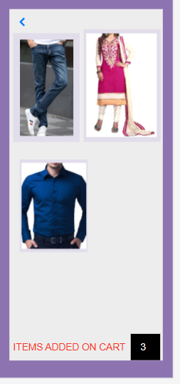

Step 4: Gather User Groups

1. Define User Groups: ○ Segment users into different categories such as age group, tech-savviness, or experience with similar products.

2. Recruit Participants: ○ Use platforms like UserTesting, surveys, or social media to find participants.

Step 5: Conduct Usability Testing

1. Deploy the Prototype: ○ Share the unique project link or invite users to test your prototype directly through Proto.io.

2. Test Sessions: ○ Conduct usability tests with users from each group, giving them specific tasks to accomplish

. 3. Collect Feedback: ○ Use Proto.io’s feedback tools or conduct interviews to gather their thoughts and experiences.

Step 6: Analyze and Evaluate

1. Data Analysis: ○ Look at how users interacted with each element. Use Proto.io’s analytics tools to draw insights.

2. Compare Groups: ○ Compare how different user groups responded to familiar vs. unfamiliar navigation.

3. Report Findings: ○ Summarize the results in a detailed report highlighting key insights, pain points, and recommendations.

## IMAGE:8[SEWING HEART-UNFAMILIAR]



RESULT:

THEREFORE WE CREATED A E-COMMERCE APP WHERE BOTH FAMILIAR AND UNFAMILIAR ICONS/ELEMENTS ARE NAVIGATED PROPERLY USING PROTO.IO AND SUCCESSFULLY PERFORMED.